Electronic Medical Record System (CMC)

Set up manual

**Prepared for:**

Dr. Chong

IT532-01 Data Warehouse

California Lutheran University

Fall Term 2018

Yu-Chun, Chou

|  |
| --- |
|  |

Contents

**1.** **Create table schema in Data warehouse** 1

• Create data warehouse in database 1

• Create fact table schema 1

• Use SSMS script generate function to generate schema from CMC_7_Database 1

• Adjust physician schema 5

• Add dimension key column 5

• Use the original ID to generate dimension table key 6

• Use SSMS script generate function to generate schema from AdventureWorksDW2012 6

• Modify dimension schema to DROP original primary key 6

• modify dimension schema to add new primary key 6

**2.** **ETL data** 8

• ETL dimension table Physicians data 8

• ETL fact table data 10

• Generate mock date data 11

**3.** **OLAP** 12

• Make sure the data source priviledge is open 12

• Create cube 12

• Rollup and drill down 16

• KPI 17

• Drill through 18

**4.** **Report** 20

• Pivot table 20

# **Create table schema in Data warehouse**

* Create data warehouse in database

Create database CMC_DW;

* Create fact table schema

USE [CMC_DW]

GO

/****** Object: Table [dbo].[fact] Script Date: 10/26/2018 11:04:16 PM ******/

SET ANSI_NULLS ON

GO

SET QUOTED_IDENTIFIER ON

GO

CREATE TABLE [dbo].[fact](

[order_id] [char](6) NULL,

[pharmacyKey] [char](6) NULL,

[physicianKey] [char](6) NULL,

[patientKey] [char](6) NULL,

[dateKey] [int] NULL,

[medicationKey] [char](6) NULL,

[unitCost] [money] NULL,

[dosage] [int] NULL,

[quantity] [int] NULL

) ON [PRIMARY]

GO

* Use SSMS script generate function to generate schema from CMC_7_Database

|  |  |
| --- | --- |
| Medication | Schema and data |
| Pharmacy | Schema and data |
| Physicians | Schema and data |
| Patients | Schema and data |

1. In SSMS, right click CMC_7_Database

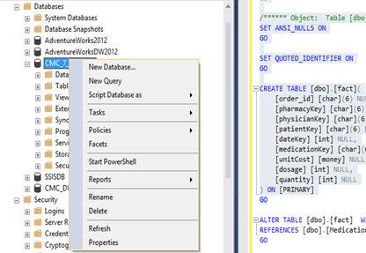

1. Choose Tasks🡪Generate Scripts

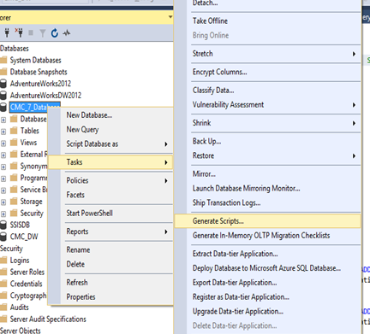

1. Click next button

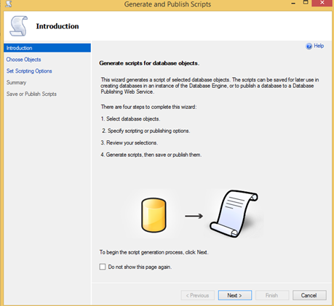

1. Click select specific database objects , and choose medication,patients,pharmacy,physicians ,click next button

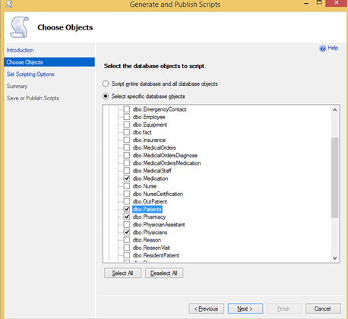

1. Click Advanced

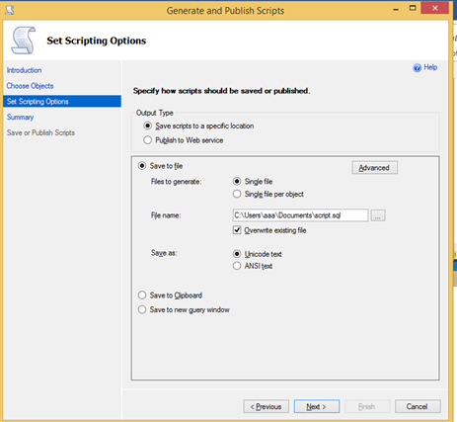

1. In ‘types of data to script’ option, select ‘schema and data’, click OK

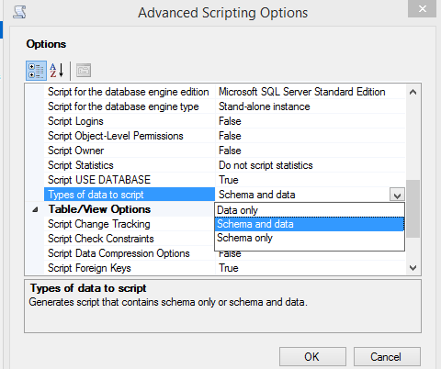

1. Choose the script location, click next button



1. Click next ,generate the script

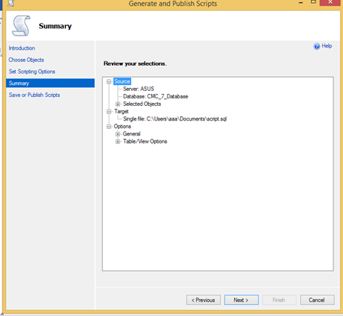

1. In CMC_DW, run the generate script to create dimension schema and data

* Adjust physician schema

USE [CMC_DW]

alter table physicians

add city varchar(35)

alter table physicians

add state char(2)

* Add dimension key column

USE [CMC_DW]

ALTER TABLE pharmacy

add pharmacyKey char(6);

ALTER TABLE physicians

add physicianKey char(6);

ALTER TABLE medication

add medicationKey char(6);

ALTER TABLE patients

add patientKey char(6);

* Use the original ID to generate dimension table key

USE [CMC_DW]

update pharmacy set pharmacyKey = substring(pharmacyID,3,100)

update physicians set physicianKey = substring(p_employeeid,2,100)

update patients set patientKey = substring(patientID,2,100)

update medication set medicationKey = substring(medicationID,2,100)

* Use SSMS script generate function to generate schema from AdventureWorksDW2012

|  |  |
| --- | --- |
| DimDate | Schema and data |
| DimGeography | Schema and data |

* Modify dimension schema to DROP original primary key

//must run statement after statement

ALTER TABLE patients

DROP constraint Patients_FK1;

ALTER TABLE patients

DROP constraint Patients_FK2;

ALTER TABLE pharmacy

DROP constraint pharmacy_pk;

ALTER TABLE physicians

DROP constraint physicians_pk;

ALTER TABLE medication

DROP constraint medication_pk;

ALTER TABLE patients

DROP constraint patients_pk;

* modify dimension schema to add new primary key

//must run statement after statement

ALTER TABLE Pharmacy

alter column pharmacykey char(6) NOT NULL;

ALTER TABLE pharmacy

ADD PRIMARY KEY (pharmacykey);

ALTER TABLE physicians

alter column physiciankey char(6) NOT NULL;

ALTER TABLE physicians

ADD PRIMARY KEY (physiciankey);

ALTER TABLE medication

alter column medicationkey char(6) NOT NULL;

ALTER TABLE medication

ADD PRIMARY KEY (medicationkey);

ALTER TABLE patients

alter column patientkey char(6) NOT NULL;

ALTER TABLE patients

ADD PRIMARY KEY (patientkey);

# **ETL data**

* ETL dimension table Physicians data

1. Follow IT-532-01 in class exercise ETL
2. Create SSIS project
3. Create connection manager

|  |  |
| --- | --- |
| CMC_7_Database |  |
| CMC_DW |  |

1. Create control flow , data flow
2. in data flow , choose CMC_7_Database connection manager as source as below

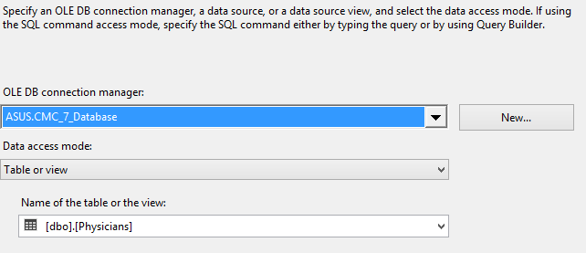

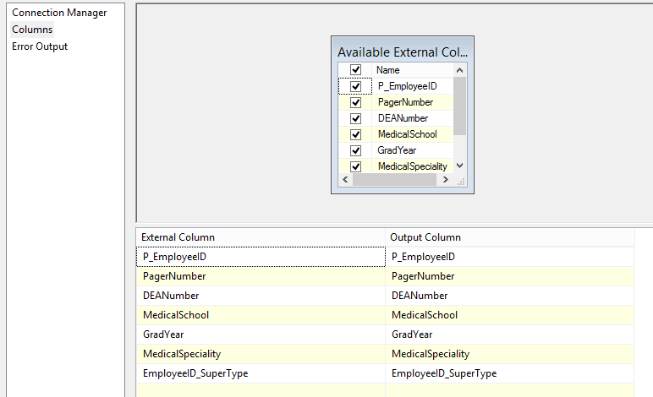

1. in data flow, create a lookup by the settings as below

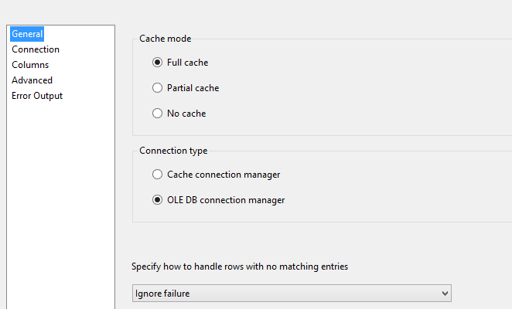

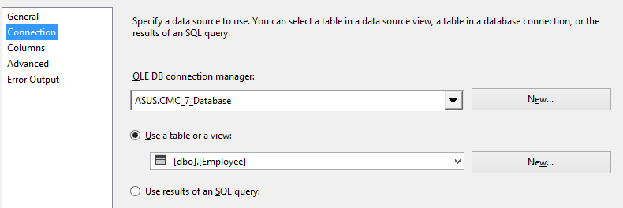

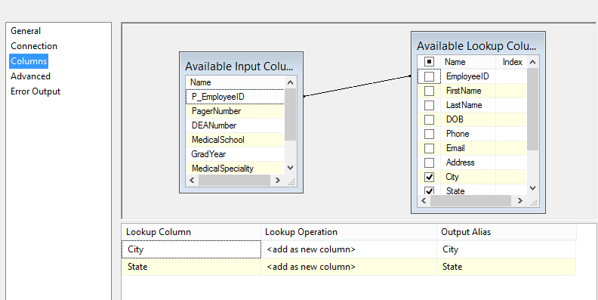

1. in data flow , choose CMC_DW connection manager as destination

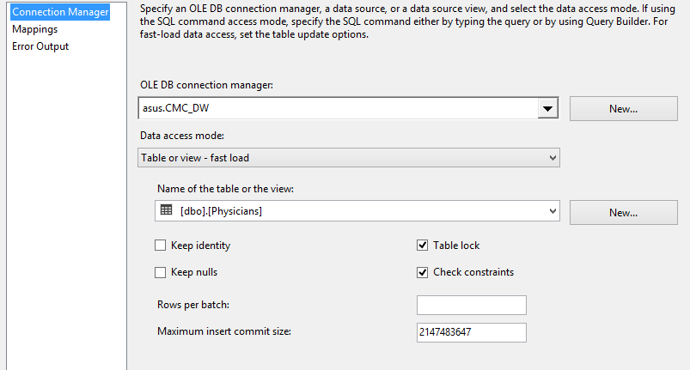

* ETL fact table data

1. Follow IT-532-01 in class exercise ETL
2. Use the setting as below

|  |  |
| --- | --- |
| Source | * CMC_7_Database * Table : medicalOrder |
| lookup | MedicialOrdersmedication  Join : order_id  Output : medicationID , Dosage,Quantity |
| lookup | MedicialOrdersmedication  Join : medication_id  Output : unit_cost |
| lookup | pharmacy  Join : pharmacy_id |
| lookup | physicians  Join : P_employee_id |
| lookup | Patients  Join : P_employee_id🡪seeing_ P_employee_id  Output :Patient_id |
| lookup | Date  Join :datekey |
| Destination | * CMC_DW * Table : fact |

1. Modify fact table FK data

update fact set pharmacyKey = substring(pharmacyKey,3,100)

update fact set physicianKey = substring(physicianKey,2,100)

update fact set patientKey = substring(patientKey,2,100)

update fact set medicationKey = substring(medicationKey,2,100)

* Generate mock date data

UPDAte fact set datekey= cast(FLOOR(RAND(CHECKSUM(NEWID()))*(2007-2005+1)+2005) as char(4)) + RIGHT('00'+cast(FLOOR(RAND(CHECKSUM(NEWID()))*(12-1+1)+1) as varchar(2)),2) + RIGHT('00'+cast(FLOOR(RAND(CHECKSUM(NEWID()))*(28-1+1)+1) as varchar(2)),2)

# **OLAP**

## Make sure the data source priviledge is open

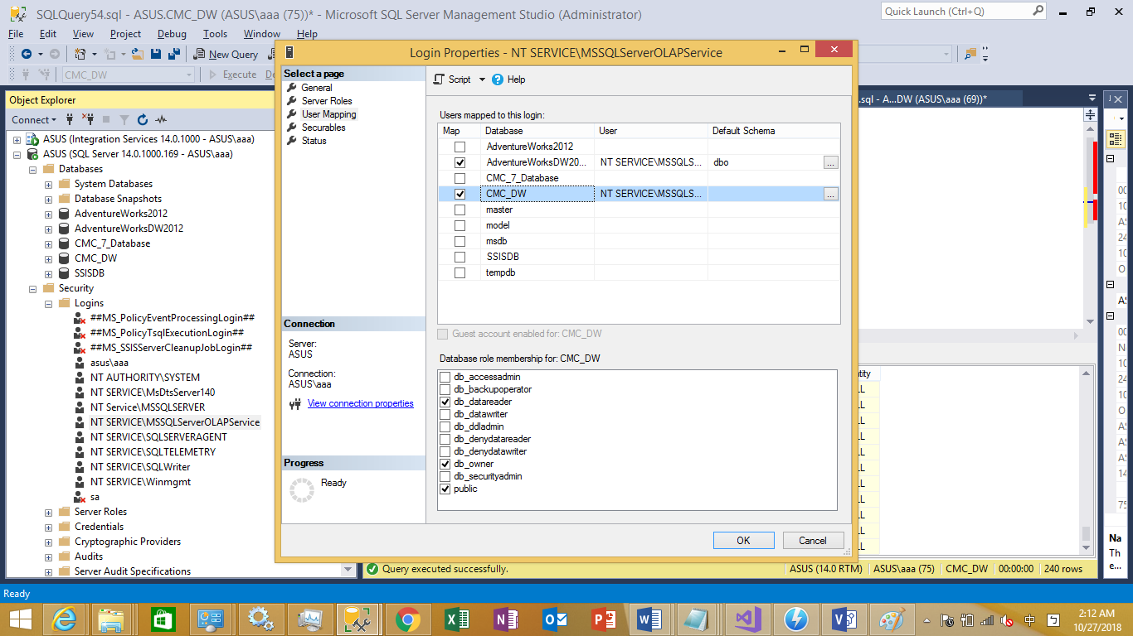

## Create cube

1. Create data source using CMC_DW
2. Create data source view using all tables in CMC_DW

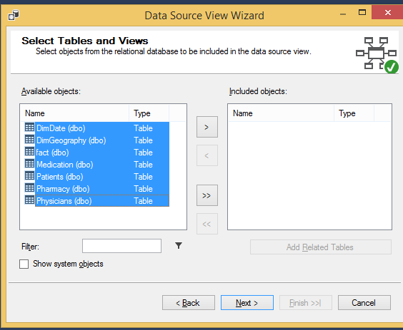

1. Create dimension using dimdate, follow the step of in-class exercise

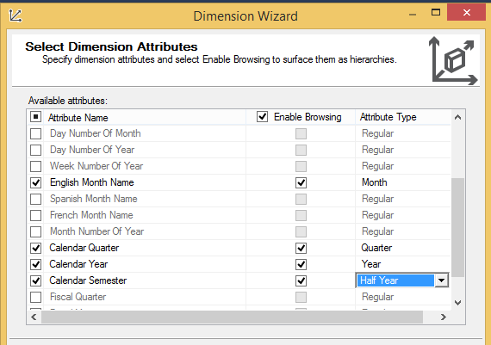

1. Create dimension using dimgeography,

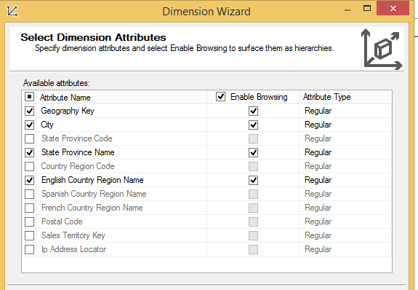

1. Create medication dimension

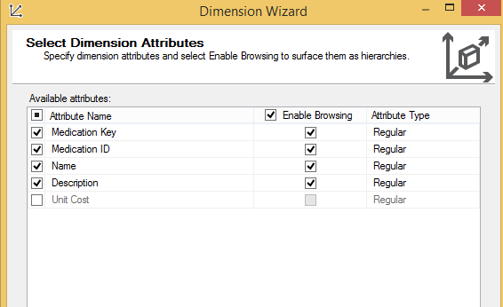

1. Create patient dimension

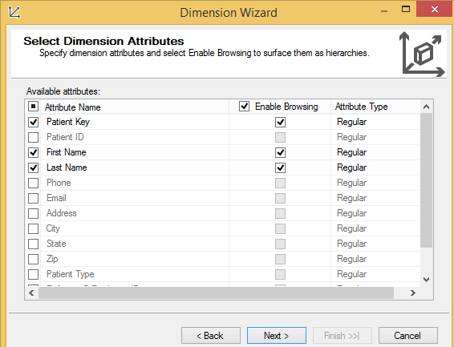

1. Create pharmacy and physician dimension
2. Create cube

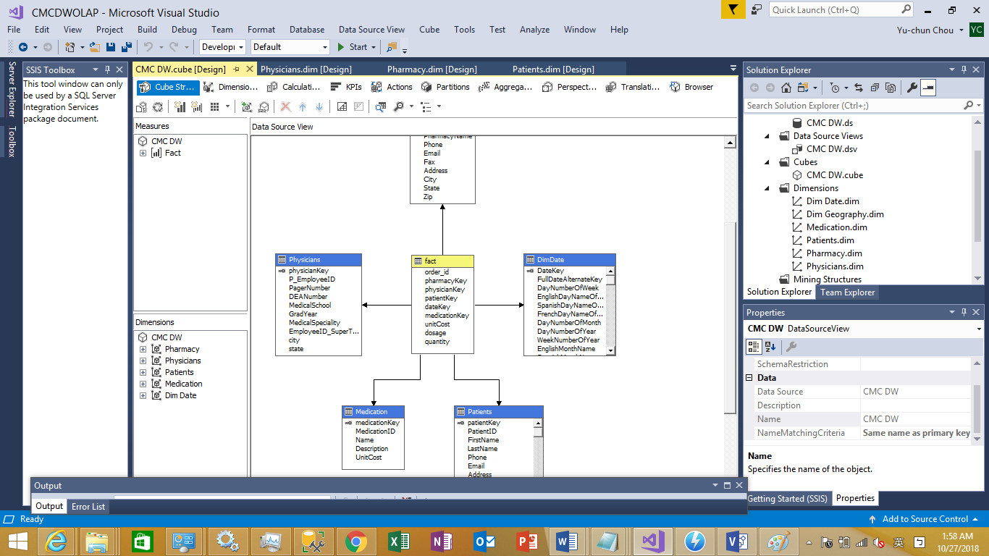

1. Deploy

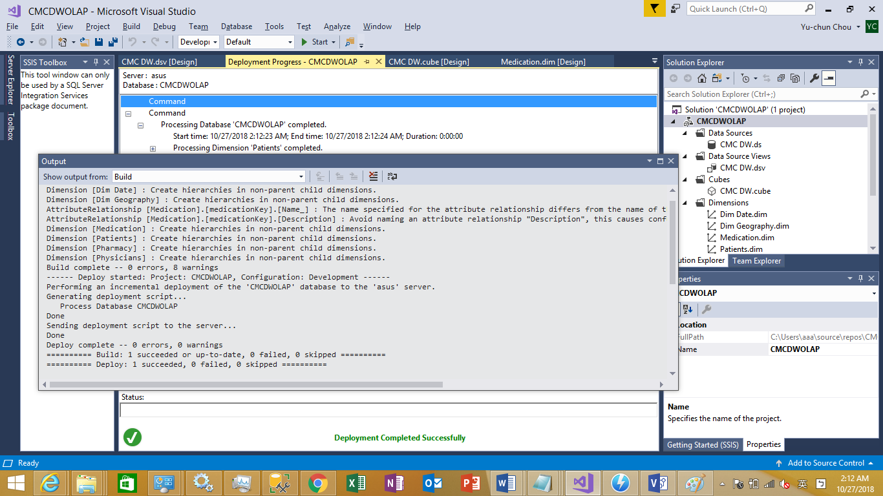

* Rollup and drill down

1. Use the criteria to query the cube

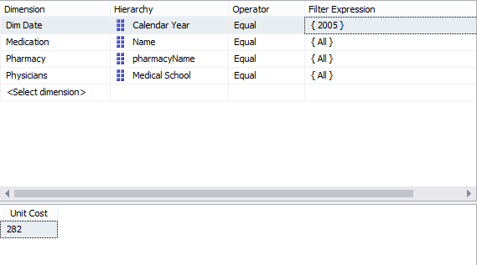

1. Use the rollup criteria to query the cube

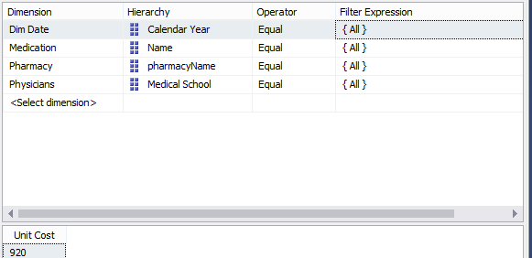

1. Drilldown using quarter

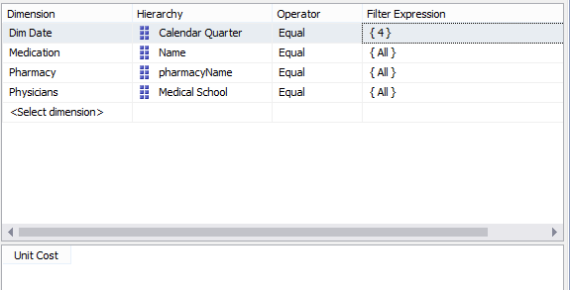

## KPI

1. Add ‘count of column’ to cube
2. Follow IT-532-01 to create KPI
3. In the **Name** box, change the name of this new calculated measure to **[average patient costs]**
4. In the **Expression** box, create the following MDX expression:

([Measures].[Sales Amount]-[Measures].[Total Product Cost])/[Measures].[Sales Amount]

1. Set KPI goal

Case

When [Patients].[PatientType].CurrentMember Is

[Patients].[PatientType].[O]

Then 100

When [Patients].[PatientType].CurrentMember Is

[Patients].[PatientType].[R]

Then 200

Else 100

End

1. Set KPI status

Case

When KpiValue( "Hospital average medication cost" ) /

KpiGoal ( "Hospital average medication cost" ) >= .90

Then 1

When KpiValue( "Hospital average medication cost" ) /

KpiGoal ( "Hospital average medication cost" ) < .90

And

KpiValue( "Hospital average medication cost" ) /

KpiGoal ( "Hospital average medication cost" ) >= .80

Then 0

Else -1

End

* Drill through

1. Follow IT-532-01 to create drill through action
2. The setting is as below

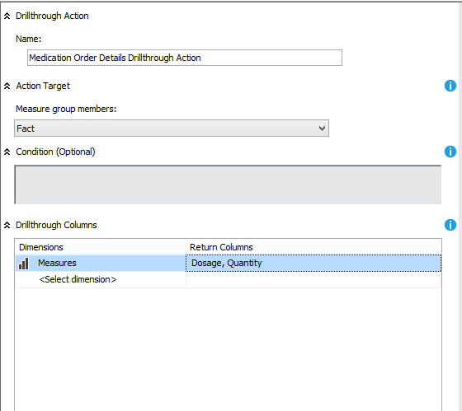

1. Click the ‘additional properties’

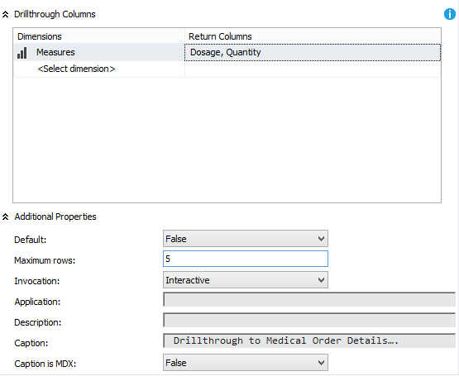

1. In browser, open excel

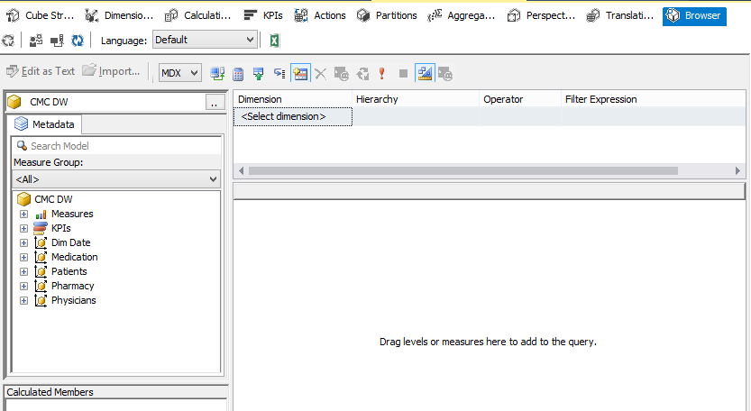

1. In excel, select calendar as filter and choose 2005, and select unit cost in values

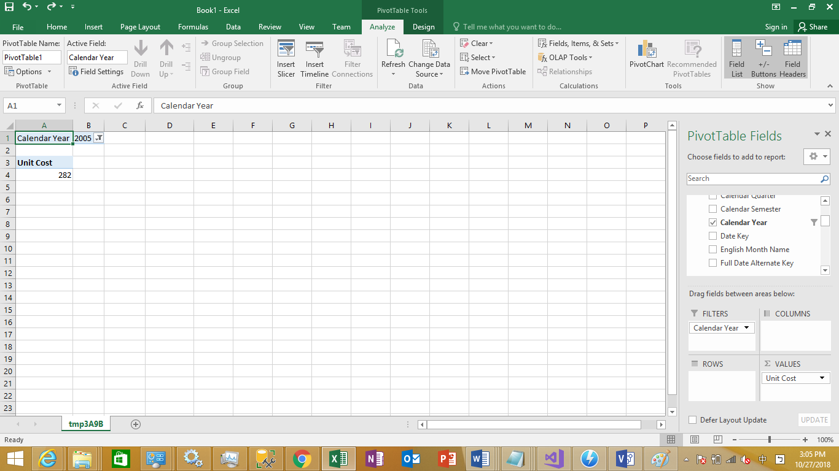

1. In unit cost result, right click , point to **Additional Actions**, and then click **Drillthrough to Order Details**.
2. New drill through result will show ,now we limit to 5

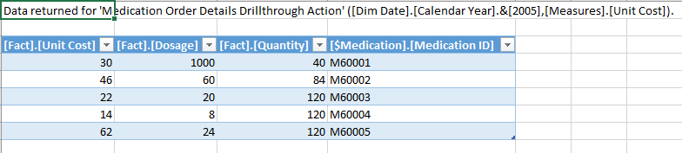

# **Report**

* Pivot table

|  |  |  |  |  |  |  |  |  |  |  |  |  |
| --- | --- | --- | --- | --- | --- | --- | --- | --- | --- | --- | --- | --- |
|  | **Column Labels** |  |  |  |  |  |  |  |  |  |  |  |
|  | **Dosage** |  |  | **Quantity** |  |  | **Unit Cost** |  |  | **Total Dosage** | **Total Quantity** | **Total Unit Cost** |
| **Row Labels** | **2005** | **2006** | **2007** | **2005** | **2006** | **2007** | **2005** | **2006** | **2007** |  |  |  |
| Acidity | 10 | 80 | 110 | 16 | 128 | 176 | 2.5 | 20 | 27.5 | 200 | 320 | 50 |
| Allergy medication | 10 | 18 | 12 | 150 | 270 | 180 | 17.5 | 31.5 | 21 | 40 | 600 | 70 |
| Diabetic medicines | 30 | 36 | 54 | 150 | 180 | 270 | 77.5 | 93 | 139.5 | 120 | 600 | 310 |
| Sudafed | 1000 | 1500 | 2500 | 40 | 60 | 100 | 30 | 45 | 75 | 5000 | 200 | 150 |
| Theraflu | 135 | 60 | 105 | 189 | 84 | 147 | 103.5 | 46 | 80.5 | 300 | 420 | 230 |
| Thyroid medication | 45 | 30 | 25 | 270 | 180 | 150 | 49.5 | 33 | 27.5 | 100 | 600 | 110 |
| Unknown | 0 | 0 | 0 | 0 | 0 | 0 | 0 | 0 | 0 | 0 | 0 | 0 |
| **Grand Total** | **1230** | **1724** | **2806** | **815** | **902** | **1023** | **280.5** | **268.5** | **371** | **5760** | **2740** | **920** |